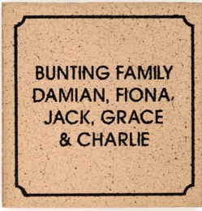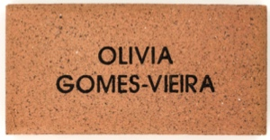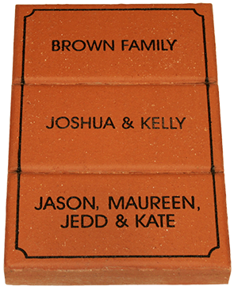

|  |  |  |  |  |  |  |
| --- | --- | --- | --- | --- | --- | --- |
| **CONTACT DETAILS AND PAYMENT OPTIONS :** | | | | | | |
| **Name** | | | **Phone** | | **Donation Amount** | |
|  | | |  | | $ | |
| **Payment Options** (please circle) **: CASH CHEQUE CARD** | | | | | | |
| Cheques to be made out to : | | {Account Details} | | | | |
| Credit Card Payments Option : Credit Card Type (please circle) Visa / Master Card | | | | | | |
| Name on Credit Card : |  | | | | | |
| Credit Card Number | | | | Expiry Date | | CRC Number |

/

Raise some much needed funds for our P&C and become a permanent part of our schools history!

In honour of your generous contribution, a personalised engraved paver(s) of your creation will be placed between the old and new buildings, when our performing arts / gymnasium is built.

**TICK**

**OPTION 2 $45**

**Double Name**

**(up to 6 lines of text)**

**OPTION 1 $25**

**Standard Name**

**(up to 3 lines of text)**

**TICK**

**TICK**

**OPTION 3 $70**

**Triple Name**

**(up to 9 lines of text)**

**OFFER CLOSES {date}**

**PLEASE COMPLETE THE PAVER DETAILS ON THE REAR OF THIS FORM**

**FUNDRAISING FOR A BETTER FUTURE**

**INSTRUCTIONS FOR COMPLETING THIS FORM**

|  |  |  |  |  |  |  |  |  |  |  |  |  |  |  |  |  |  |  |  |  |  |  |  |  |  |  |  |  |  |  |  |  |  |
| --- | --- | --- | --- | --- | --- | --- | --- | --- | --- | --- | --- | --- | --- | --- | --- | --- | --- | --- | --- | --- | --- | --- | --- | --- | --- | --- | --- | --- | --- | --- | --- | --- | --- |
| **L 1** |  |  |  |  |  |  |  |  |  |  |  |  |  |  |  |  |  |  |  |  |  |  |  |  |  |  |  |  |  |  |  |  |  |
|  |  |  |  |  |  |  |  |  |  |  |  |  |  |  |  |  |  |  |  |  |  |  |  |  |  |  |  |  |  |  |  |  |  |
| **L 2** |  |  |  |  |  |  |  |  |  |  |  |  |  |  |  |  |  |  |  |  |  |  |  |  |  |  |  |  |  |  |  |  |  |
|  |  |  |  |  |  |  |  |  |  |  |  |  |  |  |  |  |  |  |  |  |  |  |  |  |  |  |  |  |  |  |  |  |  |
| **L 3** |  |  |  |  |  |  |  |  |  |  |  |  |  |  |  |  |  |  |  |  |  |  |  |  |  |  |  |  |  |  |  |  |  |

ALL PAVERS

AREA 1

ENGRAVING DETAILS – MAX 17 CHARACTERS PER LINE

Please print clearly using ALL CAPITAL. Max 3 lines per paver.

Each box represents a character (letter, number, punctuation mark or space). No hand drawings.

**OPTION 1** – COMPLETE UP TO 3 LINES IN AREA 1

**OPTION 2** - COMPLETE UP TO 6 LINES FROM AREAS 1 AND 2

**OPTION 3** – COMPLETE UP TO 9 LINES FROM AREAS 1, 2 AND 3.

|  |  |  |  |  |  |  |  |  |  |  |  |  |  |  |  |  |  |  |  |  |  |  |  |  |  |  |  |  |  |  |  |  |  |
| --- | --- | --- | --- | --- | --- | --- | --- | --- | --- | --- | --- | --- | --- | --- | --- | --- | --- | --- | --- | --- | --- | --- | --- | --- | --- | --- | --- | --- | --- | --- | --- | --- | --- |
| **L 1** |  |  |  |  |  |  |  |  |  |  |  |  |  |  |  |  |  |  |  |  |  |  |  |  |  |  |  |  |  |  |  |  |  |
|  |  |  |  |  |  |  |  |  |  |  |  |  |  |  |  |  |  |  |  |  |  |  |  |  |  |  |  |  |  |  |  |  |  |
| **L 2** |  |  |  |  |  |  |  |  |  |  |  |  |  |  |  |  |  |  |  |  |  |  |  |  |  |  |  |  |  |  |  |  |  |
|  |  |  |  |  |  |  |  |  |  |  |  |  |  |  |  |  |  |  |  |  |  |  |  |  |  |  |  |  |  |  |  |  |  |
| **L 3** |  |  |  |  |  |  |  |  |  |  |  |  |  |  |  |  |  |  |  |  |  |  |  |  |  |  |  |  |  |  |  |  |  |

TRIPLE PAVERS ONLY

AREA 3

|  |  |  |  |  |  |  |  |  |  |  |  |  |  |  |  |  |  |  |  |  |  |  |  |  |  |  |  |  |  |  |  |  |  |
| --- | --- | --- | --- | --- | --- | --- | --- | --- | --- | --- | --- | --- | --- | --- | --- | --- | --- | --- | --- | --- | --- | --- | --- | --- | --- | --- | --- | --- | --- | --- | --- | --- | --- |
| **L 1** |  |  |  |  |  |  |  |  |  |  |  |  |  |  |  |  |  |  |  |  |  |  |  |  |  |  |  |  |  |  |  |  |  |
|  |  |  |  |  |  |  |  |  |  |  |  |  |  |  |  |  |  |  |  |  |  |  |  |  |  |  |  |  |  |  |  |  |  |
| **L 2** |  |  |  |  |  |  |  |  |  |  |  |  |  |  |  |  |  |  |  |  |  |  |  |  |  |  |  |  |  |  |  |  |  |
|  |  |  |  |  |  |  |  |  |  |  |  |  |  |  |  |  |  |  |  |  |  |  |  |  |  |  |  |  |  |  |  |  |  |
| **L 3** |  |  |  |  |  |  |  |  |  |  |  |  |  |  |  |  |  |  |  |  |  |  |  |  |  |  |  |  |  |  |  |  |  |

DOUBLE AND TRIPLE PAVERS

AREA 2