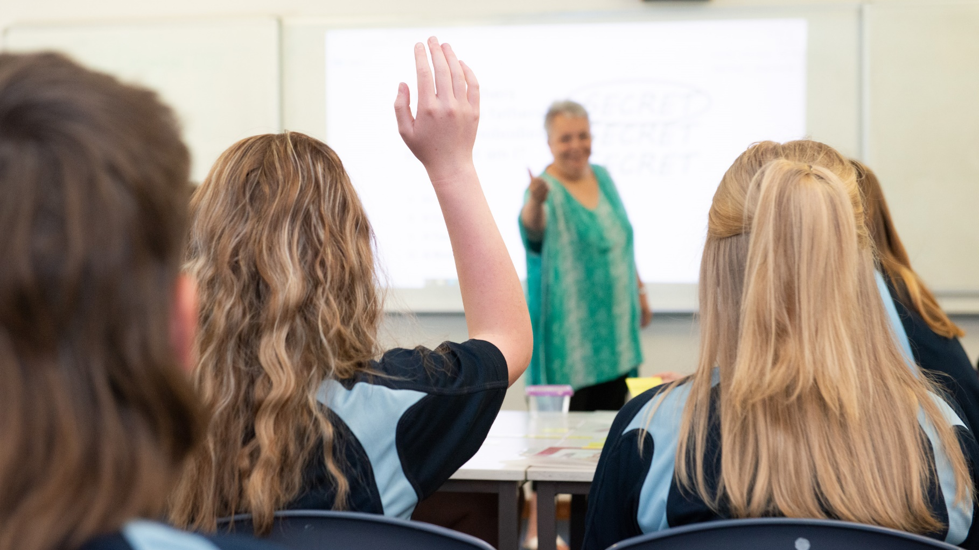

PINJARRA SENIOR HIGH SCHOOL
Assessment
2
0
2
2
Policy

PINJARRA SENIOR HIGH SCHOOL
Senior School Assessment Policy

Assessment Guideline
Pinjarra Senior Highschool (PSHS) has high expectations. It is the aim for parents, students, and staff to work together so that students maximise all opportunities for success.
On starting each course in Senior School, students must be informed in writing of the assessment program. The assessment program must include a general outline of assessment tasks which contribute to the final numerical school assessment, a timeline for completion of tasks, their marks value and their respective weightings relative to the School Curriculum and Standards Authority (SCSA) assessment requirements. Students should also be provided with a copy of the syllabus and grade related descriptors for the course/subject.
Assessment procedures must be fair, explicit, educational, comprehensive, valid and reliable. If adjustments are made to the assessment schedule, it should be done in close consultation with students.
The frequency of assessment (number of tasks) may vary from one course/subject to another. However, the assessment programme must include a range of tasks with sufficient breadth to enable comprehensive assessment of the essential content of the course/subject. Final grades for all subjects/courses will be submitted to the School Curriculum and Standards Authority.
Internal and external consensus and moderation processes are required to verify comparability of assessment within the class, between classes of the same unit/course in Senior School and between Pinjarra SHS and other schools. These processes include common assessment tasks, cross marking exercises, school moderation visits and small group moderation partnerships as well as meetings arranged by the School Curriculum and Standards Authority.
If a grade is awarded for an individual task, it serves as an indication of student progress. A final grade will be awarded at the end of each unit/course.
Parent/guardians will be notified if a student is at risk of not achieving a satisfactory grade for a course/subject.
Procedures for assessment review are available to students who believe that the school has not followed the documented assessment policy, resulting in inaccurate assessment and possible disadvantage. Students and/or parents/carers wishing to appeal their assessment on these grounds should apply in writing to the Head of Learning Area. An Application for Assessment Review Form is located on the PSHS website (quick links). NB The marking of individual tasks and allocation of grades is not subject to appeal within the Assessment Review Process. Such matters should be resolved through consultation with the class teacher and/or the Head of Learning Area.
Students may appeal their school assessment to SCSA, but only after they have exhausted the PSHS assessment review process. The grounds for appeal are the same as for the School’s assessment review process.
Teachers may use the same assessment tasks at different times in different classes in the same or previous calendar year. To ensure security of assessments, teachers will develop parallel assessment tasks for use by different classes and if necessary, modify tasks before reusing them.

Student Responsibilities
- Complete the prescribed work requirements in each course by the due date.
- Complete all assessment tasks described in the course outlines.
- Complete process work that underpins the final work submitted for assessment. This may be required to authenticate work completed out of class.
- Year 11 and 12 students must retain completed assessments until the end of SCSA Appeals process (end of school year). Students must produce assessments if SCSA requests access.
- Year 7-10 students must retain completed assessments if taking home. Teachers may retain student assessments until the close of SCSA appeals process (end of the calendar year).
- Maintain a good record of attendance, conduct and progress.
- Initiate contact with teachers concerning absences from class, missed assessments, extension requests and other issues pertaining to assessment.
- Provide appropriate notes of explanation/medical certificates to validate absences.

Teacher Responsibilities
- Develop a teaching/learning program that adheres to current School Curriculum and Standards Authority. Ensure that assessments are fair, explicit, educational, comprehensive, valid and reliable.
- Provide students with a course outline and assessment program at the commencement of the course. Inform students of specific dates for specially scheduled assessment tasks (e.g. tests, in class essays).
- For each assessment provide students with a task outline clearly stating criteria being assessed and expected standards. For each assessment task provide students with constructive written feedback using analytical marking keys.
- Maintain accurate records of student achievement and assessment. Meet Pinjarra SHS and external time frames for assessment and reporting.
- Inform students and parents/guardians of academic progress as appropriate. Including missed assessments. This may include informal contact.
- Inform students of the possible effects of standardization and moderation processes on both examination marks and school-based assessments. Conduct end of semester formal reporting.
- Years 7-10 student assessments will be retained by the school until the end of the SCSA appeal process (end of the school year). If students do take assessments home, they must produce completed work should the SCSA request a review.

Late Submissions of Assessment Tasks
Penalties for Late Work
It is the teacher’s responsibility to manage the assessment schedule.
It is the student’s responsibility to submit assessed work on time. Late submissions will attract penalties.
Late submissions will attract a 10% deduction of available marks from the assessment per working day for a four-day period. On the fifth day a zero will be recorded for the assessment task. Please Note: Workplace Learning, Excursions, Camps, Off Site days, TAFE, eg: family holidays etc, are not valid reasons to be exempt from receiving a penalty for late submissions of assignments.

Extensions
A student may apply in writing to the class teacher for an extension of the due date for an assignment. Extensions may be given at the discretion of a teacher in cases where the student has a valid reason for late submission, such as illness or significant personal problems. An ‘Application for Extension’ form is located on the Pinjarra SHS website (quick links). This form should be photocopied and submitted to the teacher prior to the assessment due date.

Absence from Class/Missed Work
General
If a student is absent from class, their ability to achieve to their potential is diminished. Extended periods of absence will result in lower levels of achievement. Significant or prolonged absences may result in a student not fulfilling the requirements of a course and being deemed as unable to be assessed. Teachers must authenticate student achievement, and this requires students to attend school regularly.

Specially Scheduled Assessment Tasks
Absence from a scheduled assessment task (including timed assessments, tests and examinations) must be explained by a medical certificate and/or supported by a letter from a parent/guardian. Where possible, satisfactory explanation of the absence will enable the student to complete that assessment task or a similar task and gain credit. In cases where a student is unable to attend school to complete a scheduled assessment task, and where appropriate supervision can be provided, the student may be given permission to complete the task at an alternative time.
Where a judgement of ‘special circumstances’ has been determined, through communication with parents/carers and in consultation with the Associate Principal and HoLA, a task may be modified accordingly. This might also involve developing an Individual Education Plan/Documented Plan and/or re-negotiated submission date. The Associate Principal, HoLA and teacher will consider fairness for all students when making decisions about adjusting timelines for a particular student.

Prolonged Absence
Where a student is unable to attend school for a lengthy period due to injury or illness, the school will endeavour to provide support to the student’s learning program. This may include a referral to external educational providers including SIDE (School of Isolated and Distance Education) to allow the student to access an educational program more suited to their needs.

Other Information
Transferring between Courses/Units/Subjects
Generally, students are advised to avoid any course/subject change because it can be detrimental to success. When a course change has been approved by PSHS, students will be given the opportunity to complete missed assessments and/or recognition of comparable achievement will be considered for credit.
All course/subject changes must have parental support and they must be approved and organised through the Associate Principal. All course changes are dependent upon the availability of a suitable replacement course/subject. Applications for course/subject changes are made to the Associate Principal in writing. Years 7-10 student Elective course changes must be completed by the end of week two of each semester. After this date, changes will only be permitted only under exceptional circumstances. Year 11 and 12 students will not be permitted to change a unit after Friday, week 4 (semester 1).

Plagiarism and Cheating
Plagiarism occurs when a student uses someone else’s work/words without acknowledging that they have done so. Cheating is copying the work of others for or an assessment task or using resources/materials that are not permitted in tests and examinations. Suspected plagiarism and/or cheating will be referred to the HOLA. Students will be interviewed to ensure procedural fairness and parents/carers will be notified. Evidence of plagiarism or cheating will be reviewed by the HOLA and Associate Principal. If it is determined that cheating and/or plagiarism has occurred, a mark of 0 will be awarded for that task.

Examinations
It is compulsory for students to attend scheduled examinations. In exceptional circumstances, special alternative arrangements may be made through the Associate Principal. Participation in unauthorised absences such as family holidays will not be accepted as an exceptional circumstance. Students will be issued with an examination timetable and a list of regulations governing examination conduct. E.g. attending exams in school uniform, arriving on time, materials permitted in exam room etc.
Students with Special Needs
Pinjarra SHS will ensure that programs are adjusted to ensure all students have the opportunity to achieve success. Students with special needs will be catered for in appropriate ways and in accordance with the authority guidelines. These include students with disabilities, specific learning difficulties, preclusive cultural beliefs or students transferring between courses and/or schools. Standards for student achievement must be applied in the same way as for all students enrolled in a unit/subject/course.
Eligible WACE examinations candidates have access to special provisions for exams through an application process to the SCSA.
Resubmission of an Assessment Task
If the teacher agrees that it is feasible, a student who has submitted a task by the due date and achieved an unsatisfactory result may apply for the opportunity to complete an alternative, comparable task under controlled conditions. A resubmitted task will be awarded no higher than a numerical score that equates to a C grade.
Assessments Affected by a Catastrophic Event (pandemic, natural disaster etc.)
The teacher/HOLA will make a professional judgement of the achievement of any students affected based on the completed assessment tasks. Parents /carers will be notified of changes to how achievement will be determined, including the possible requirement of additional assessment tasks.

